Agenda:
– Attendance
– Room change, Stat312: Starting on Tuesday, January 14, we will meet in
02-204 (Cotchett Education Building, 2nd floor)
– Discussion (text)
– JMP software (

1. What is Statistics?

Basic Definitions:

Population. Any entire collection of objects or events (people, organizations, 'widgets', phone-calls ...) which we wish to describe or draw conclusions about.

Sample. A sample is a subset of a population. Some samples are random (each object has the same probability of being in the sample). Other samples are convenience samples (non-random; e.g., take the most easily available objects).

Data. Information concerning the properties or structure of a population or sample.

Variable. A variable is any specific characteristic of objects that can be measured, counted, or quantified.

A statistic. A statistic is a number that summarizes or describes some property of a set of data (population or sample).

Descriptive statistics. The entire process of collecting and analyzing data to describe the characteristics or properties of a sample or population of objects. Often we cannot compute descriptive statistics for a large population because that would require measuring every object.

Inferential statistics. The process of drawing conclusions about a population (or populations), based on observations in a sample (or samples).
Statistical Inference: One Population

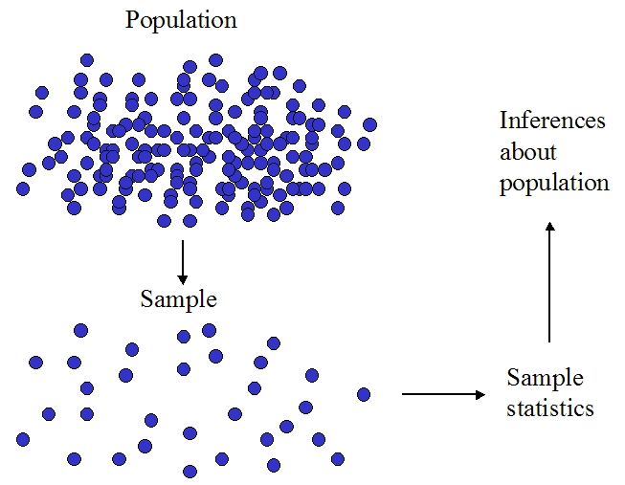

Statistical Inference: Two Populations

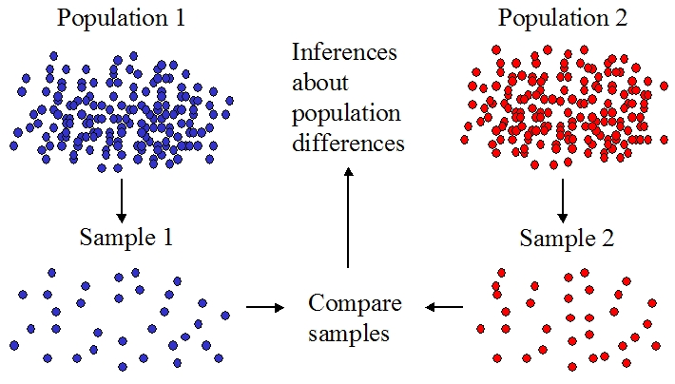

2. Excel Basics (Demonstration)

1. Make dedicated folder

C:/Statistics 251/Excel
C:/Excel

2. Save/backup your work often!

3. Basic Excel Concepts

File formats
- .xlsx (preferred)
- .xls

Columns (A, B, C, …. )
Rows (1, 2, 3, …)
Cell addresses (A1, A2, B1, B2, etc.)

Cell contents

alphanumeric string (Hello, Standard deviation, '1)
– placing an apostrophe (') before a number makes it a string (you can
no longer perform arithmetic on it)

number (1, 3.1456)

formula
– precede with "=" sign
– arithmetic operation on cells; example: =A1+A2
– or a function of a cell or cells: =sum(a1, a2)

Formatting cell contents

Decimal places: right-click > Format Cells > Number > Decimal places

Background color: right-click > Format Cells > Fill > Pattern color

Cell border: right-click > Format Cells > Border

(or use Home tab on command ribon)

Copying cell contents

– Cut-and-paste (CTRL-X, CTRL-V)
– Copy (CTRL-C, CTRL-V)
– Beware relative addressing: copying or moving a formula changes it!
– To copying values instead of formulas:
CTRL-C > right-click > Paste Special > Values
– the $ qualifier preserves a Row and/or Column in a formula when copying

Example: $A1, A$1, $A$1

Cell ranges

– Column range: e.g., A1:A10 means all cells from A1 to A10, inclusive
– Row range: e.g., A1:F1 means all cells from A1 to F1, inclusive
– Array range: e.g., A1:F5
– Helpful tip: in a formula you can refer to an entire column by typing:
A:A, F:F, etc.

Namings cells (or cell ranges)

– Highlight cell or range of cells
– Move cursor to Name Box (where red arrow below points)

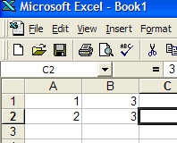

– Type in new name
– You can now use this name in cell formulas. Example: =sum(datarange)

– Be sure cursor is in Name Box, not in the cell(s) you are naming

Video (Excel tutorial): http://www.youtube.com/watch?v=8L1OVkw2ZQ8

Homework:

Stat312: Read pp. 1–14.

